GenVarX Suite - Genomic Variant Effect Predictor & Clinical Analysis Platform

1. Abstract
This project presents an end-to-end Variant Interpretation Pipeline designed to bridge the gap between raw genomic data and clinical decision-making. By integrating foundational sequence alignment algorithms with modern machine learning (AI) and medical databases, the system automates the transition from a genomic coordinate to disease association and therapeutic intervention. The system utilizes a relational database model to link disparate repositories including ClinVar, GWAS Catalog, and ChEMBL, providing a "Rosetta Stone" for deciphering the functional impact of genetic mutations.

2. Introduction

2.1 Background
The field of bioinformatics has evolved from the initial collection of protein sequences to massive whole-genome sequencing projects like the Human Genome Project. While the "what" of the human genome (the sequence strings) is largely identified, a "fundamental problem" remains: determining the structural and functional relationships of these sequences.

2.2 Problem Statement
Current clinical interpretation of genomic variants is often a "time-consuming, painstaking, and sometimes error-prone process". There is a significant "Interpretation Gap" where researchers must manually cross-reference data across siloed databases (GenBank, EMBL, SwissProt) to find the clinical significance of a specific mutation.

2.3 Proposed Solution
The proposed system is an automated, integrated pipeline that performs reciprocal database searches to resolve genomic coordinates into standardized Reference SNP IDs (RSIDs). It utilizes AI-driven predictors (SIFT/PolyPhen) to assess residue impact and aggregates clinical data to suggest targeted drug therapies.

2.4 Objectives
- To automate variant identification and coordinate-to-RSID resolution.
- To implement Predictive Modeling (Unit III syllabus) for classifying mutations as pathogenic or benign.
- To integrate Pharmacogenomics data from ChEMBL for therapeutic discovery.

3. System Requirements

3.1 Hardware Requirements
- Processor: High-performance CPU capable of handling exponentially growing computational steps for sequence comparisons.
- Memory: Minimum 8GB RAM (optimized for N-dimensional hypercube matrix storage).
- Graphics: WebGL-compatible GPU for 3D molecular visualization.

3.2 Software Requirements
- Operating System: Cross-platform compatibility (Windows, MacOS, UNIX).
- Interface: Web-based interface for flexibility and ease of access.
- Data Handling: API clients for real-time querying of NCBI and EBI repositories.

4. Technology Stack
- Languages: Python/Perl for backend automation scripts.
- Database: Relational Model for structured data exchange using ASN.1 formats.
- Machine Learning: Neural Networks (Hidden Markov Models) for gene and effect prediction.
- Visualization: WebGL2 for Impact Assessment modules and 3D subsystems.

5. Project Structure
- Input Module: Accepts genomic coordinates (e.g., 17:7673802:C:T) or RSIDs.
- Alignment & Mapping: Uses Global (Needleman-Wunsch) or Local (Smith-Waterman) algorithms to identify base substitutions.
- Predictive Modeling Engine: Runs AI classifiers to determine if a protein change is "Conservative" or "Moderate".
- Clinical Annotation Module: Aggregates findings from ClinVar (VCF) and GWAS (TSV).
- Drug Discovery Interface: Queries the ChEMBL database for bioactive compounds targeting specific genes (e.g., APC, TP53).

Architecture Diagrams

1. System Architecture Overview

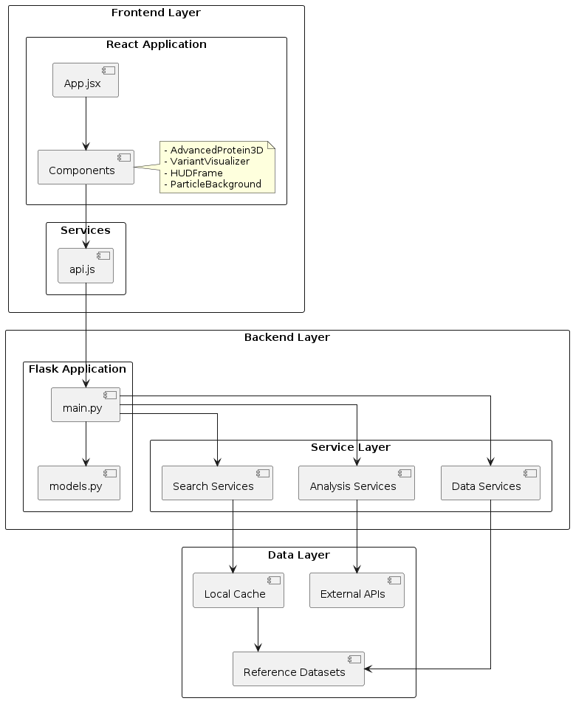

2. Service Layer Architecture
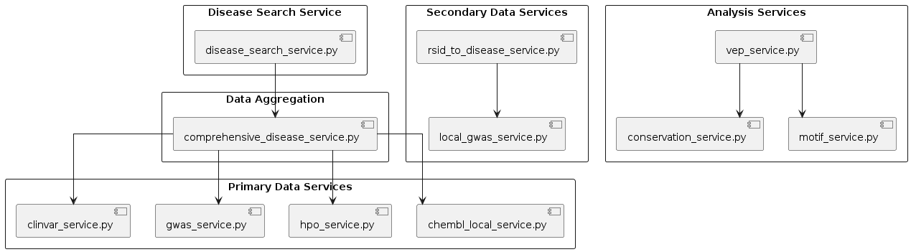

3. Data Flow Architecture

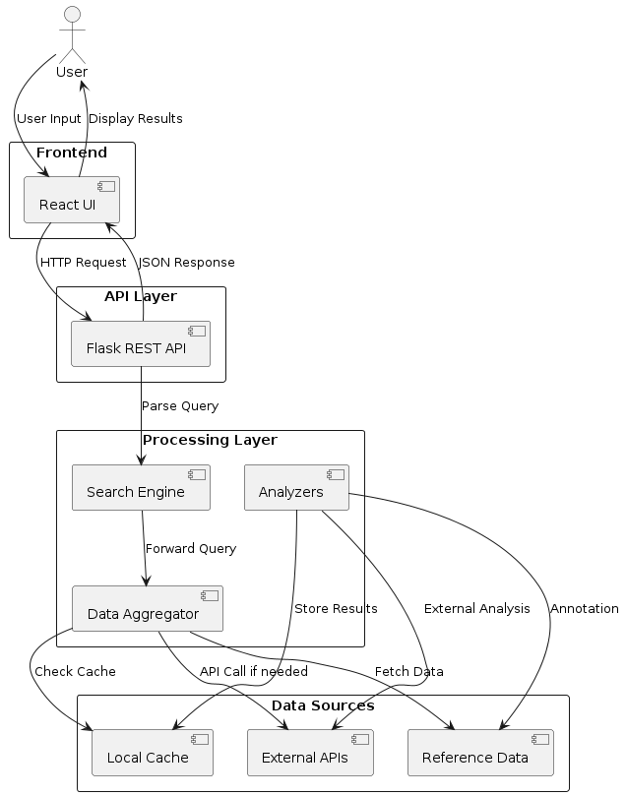

4. Component Interaction Diagram
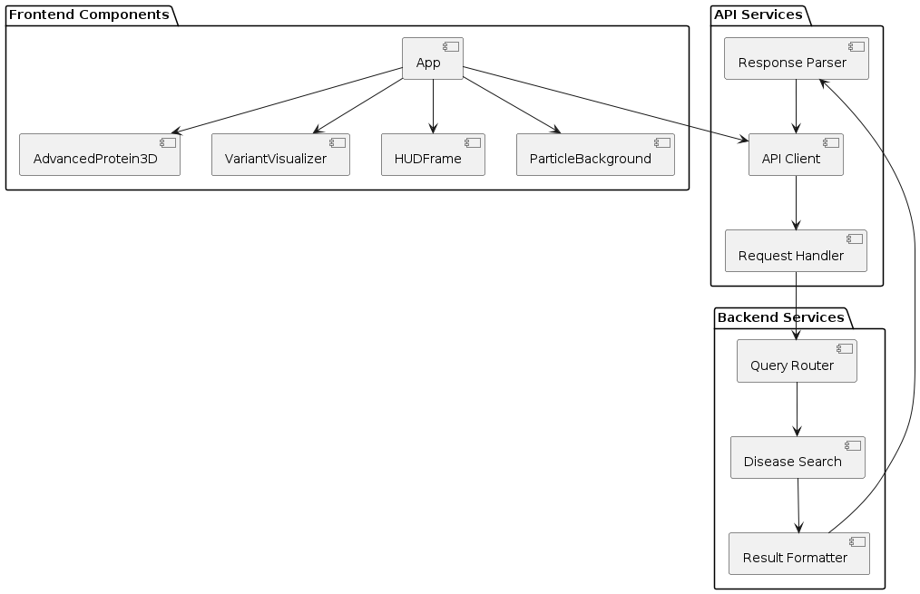

5. Database and Data Models
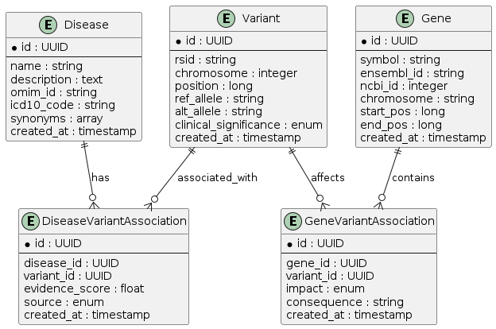

6. API Endpoint Architecture
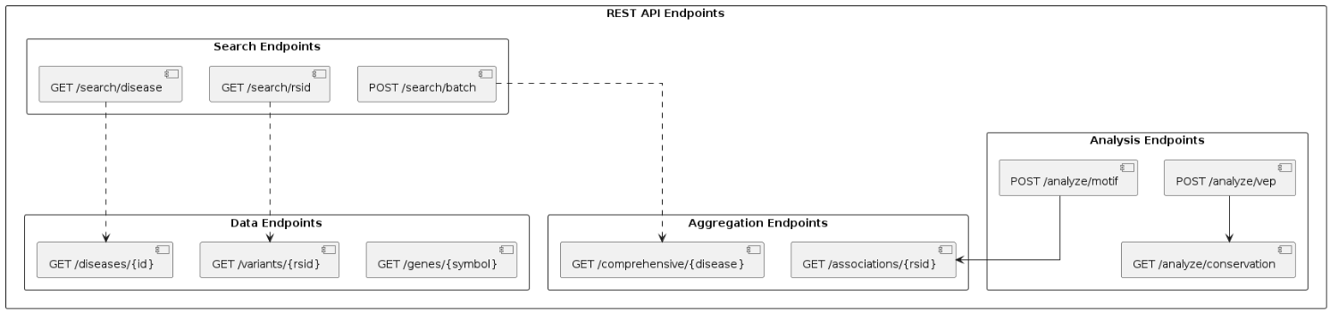

7. Deployment Architecture

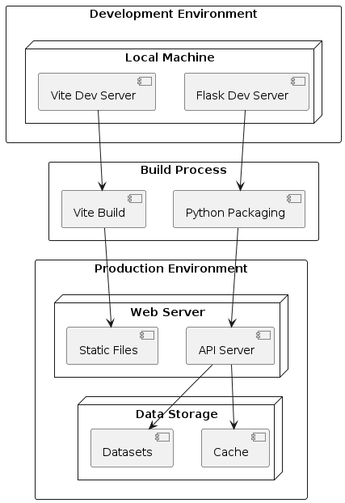```

8. Technology Stack
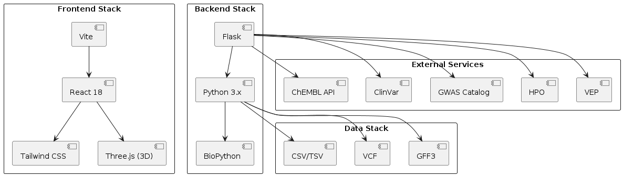

9. Request/Response Flow
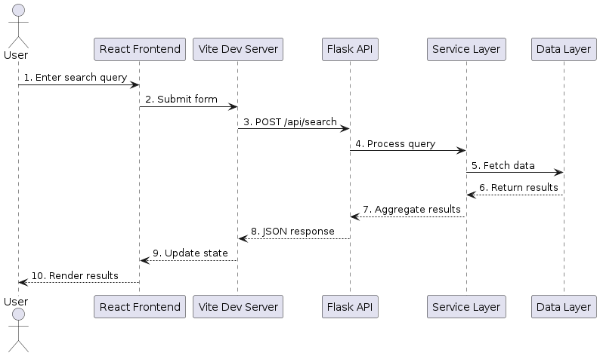

10. Error Handling Flow

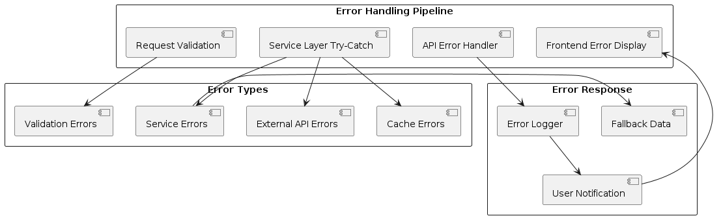

Screenshots

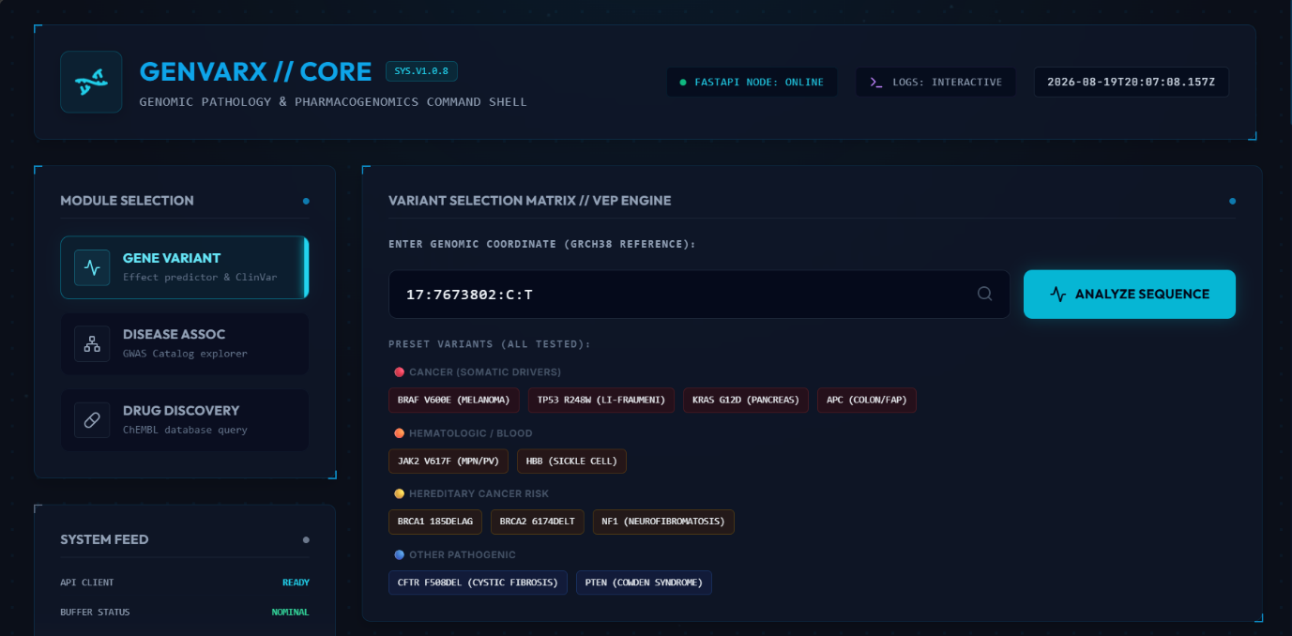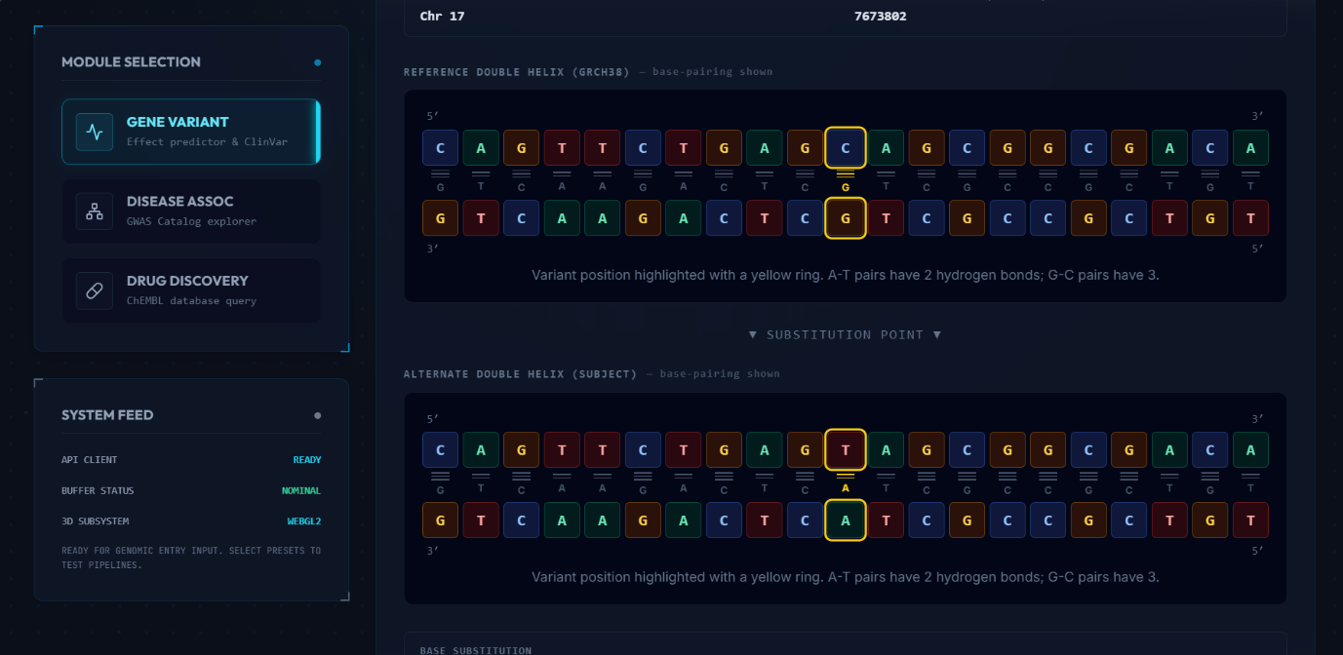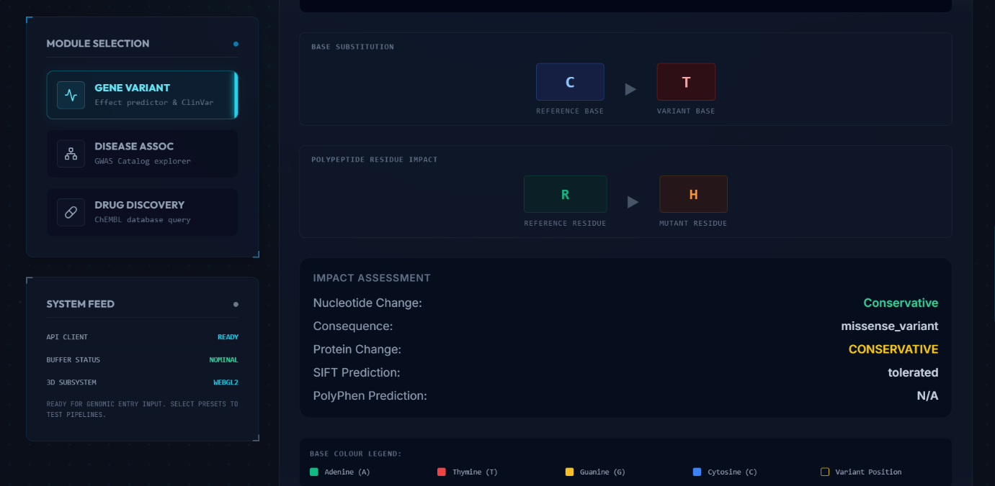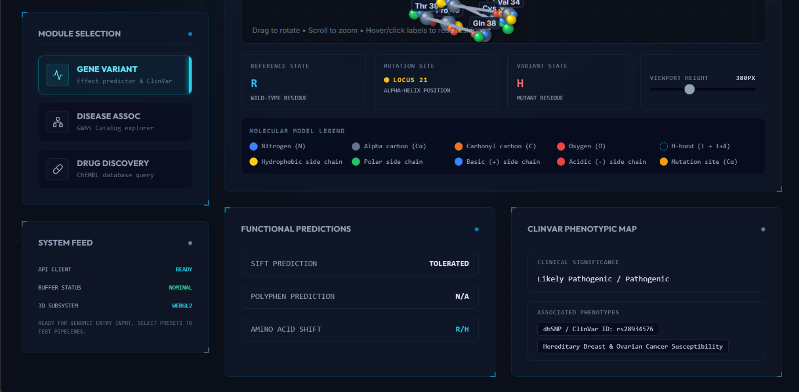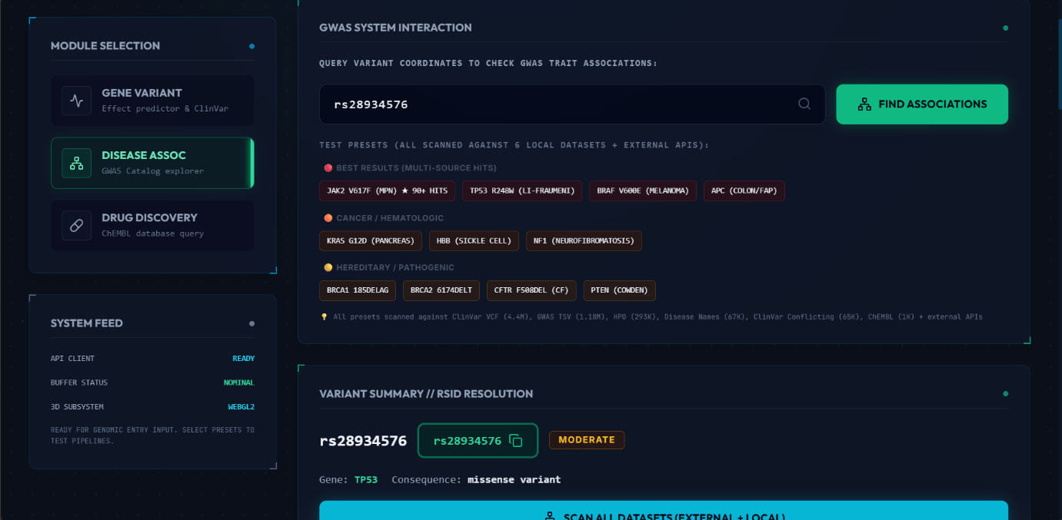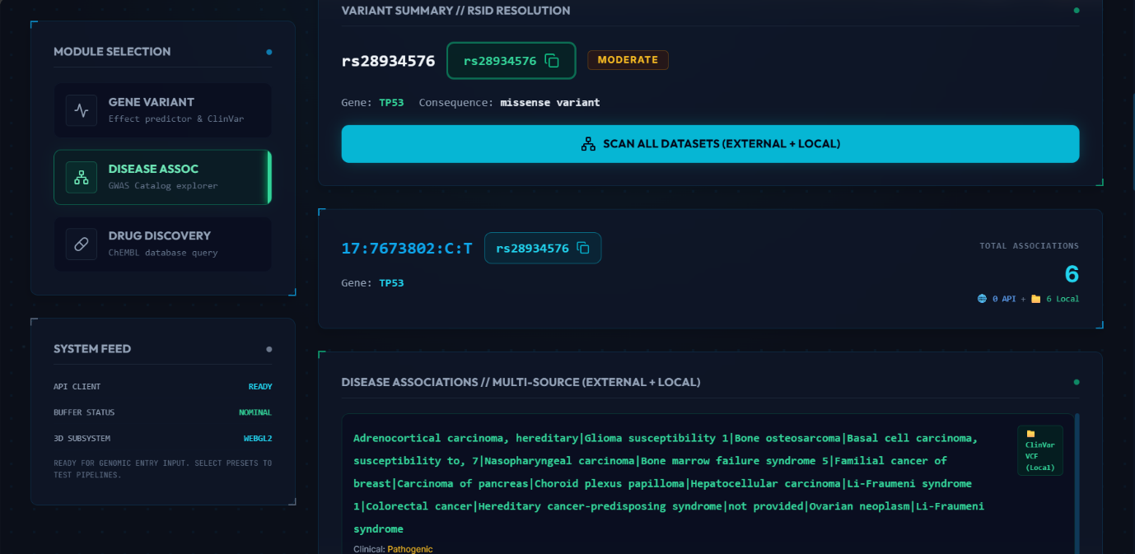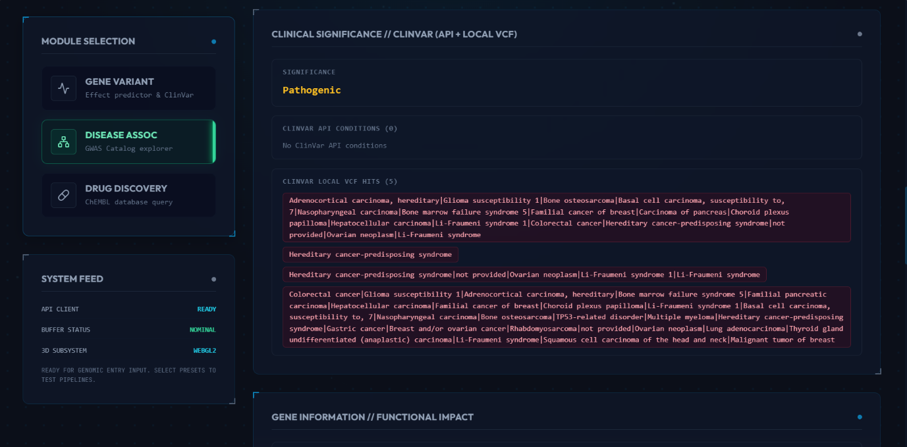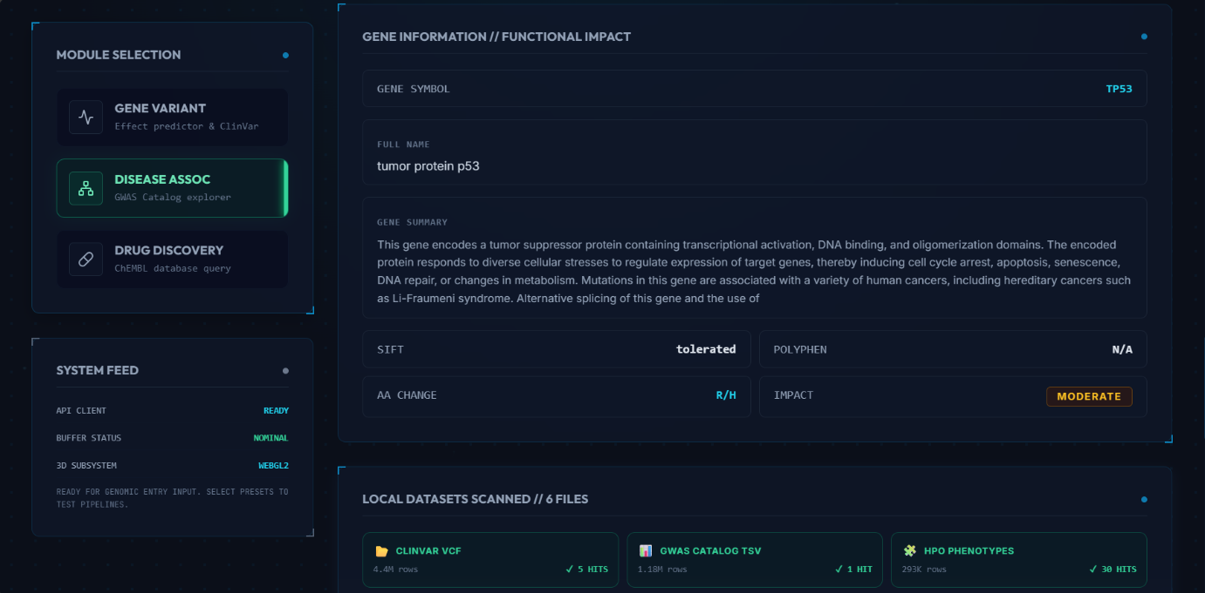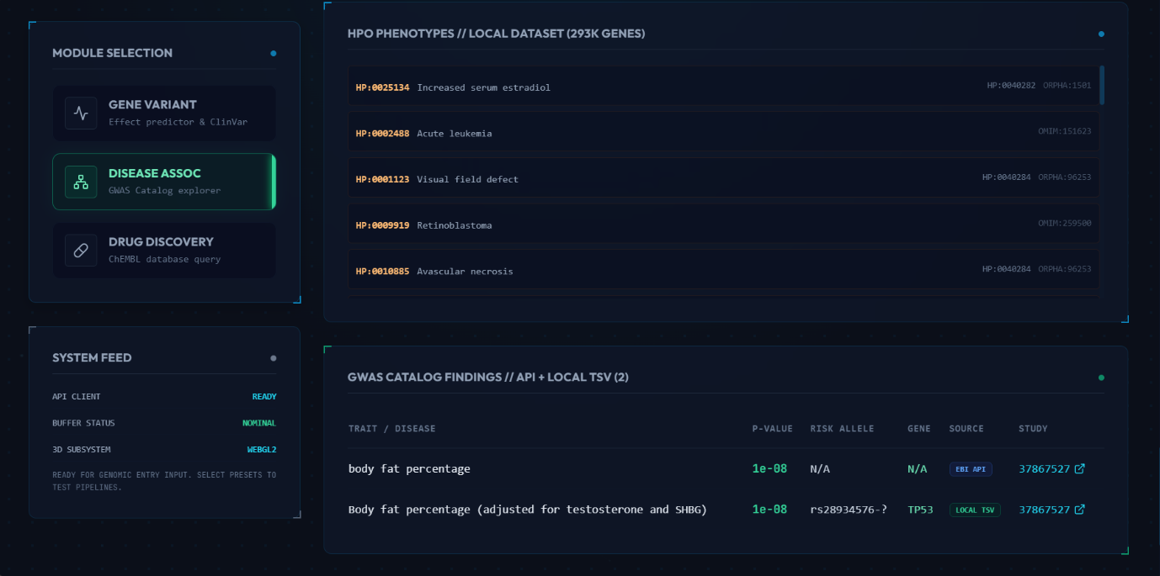

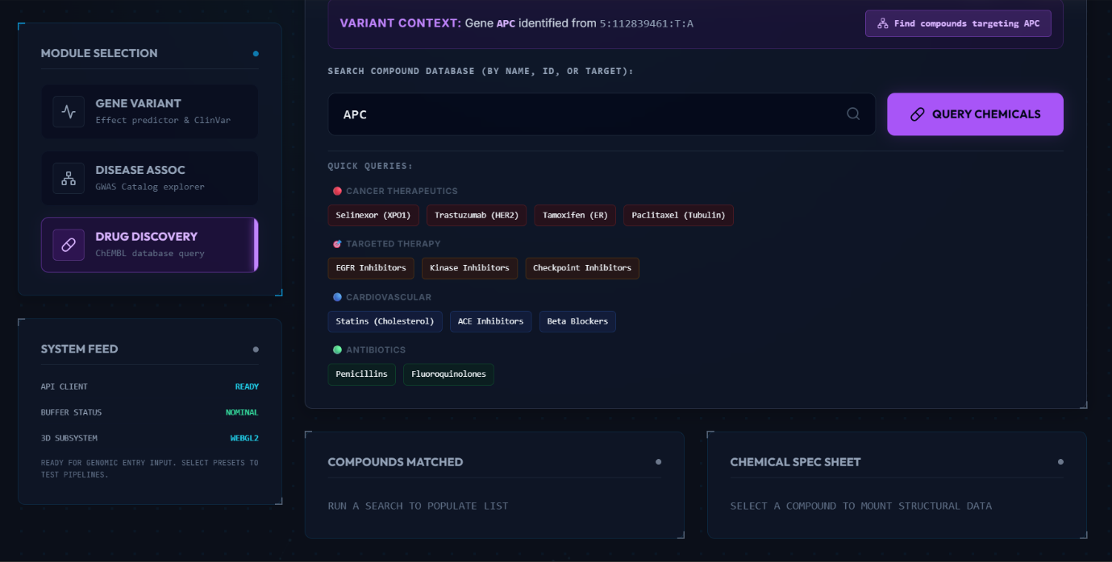

Code:

App.jsx
import React, { useState, useEffect } from 'react';
import { annotateVariant, fetchGwasAssociations, gwasDatasetAnalysis, getDiseaseAssociations, getDatasetsSummary, searchCompounds, getCompound, getCompoundsByGene, getDiseasesByRsid, getComprehensiveDisease } from './services/api';
import { Dna, Search, AlertTriangle, Activity, ShieldAlert, Loader2, Database, Pill, Network, Terminal, Shield, RefreshCw, Copy, ExternalLink, CheckCircle2 } from 'lucide-react';
import { motion, AnimatePresence } from 'framer-motion';
import VariantVisualizer from './components/VariantVisualizer';
import AdvancedProtein3D from './components/AdvancedProtein3D';
import ParticleBackground from './components/ParticleBackground';
import HUDFrame from './components/HUDFrame';

export default function App() {
const [activeModule, setActiveModule] = useState('variant');
const [variantInput, setVariantInput] = useState('17:43044295:G:A');
const [loading, setLoading] = useState(false);
const [data, setData] = useState(null);
const [error, setError] = useState(null);

const [gwasInput, setGwasInput] = useState('17:43044295:G:A');
const [gwasLoading, setGwasLoading] = useState(false);
const [gwasData, setGwasData] = useState(null);
const [gwasError, setGwasError] = useState(null);
const [datasetAnalysis, setDatasetAnalysis] = useState(null);
const [diseaseAssoc, setDiseaseAssoc] = useState(null);

// RSID lookup state
const [selectedRsid, setSelectedRsid] = useState(null);
const [rsidDiseases, setRsidDiseases] = useState(null);
const [rsidLoading, setRsidLoading] = useState(false);
const [rsidError, setRsidError] = useState(null);

// RSID Search Module State
const [rsidSearchInput, setRsidSearchInput] = useState('rs6414541');
const [rsidSearchLoading, setRsidSearchLoading] = useState(false);
const [rsidSearchResults, setRsidSearchResults] = useState(null);
const [rsidSearchError, setRsidSearchError] = useState(null);

// Comprehensive disease lookup (multi-API aggregator)
const [comprehensiveDisease, setComprehensiveDisease] = useState(null);
const [compLoading, setCompLoading] = useState(false);
const [compError, setCompError] = useState(null);
const [copySuccess, setCopySuccess] = useState(false);

const [compoundQuery, setCompoundQuery] = useState('selinexor');
const [compoundLoading, setCompoundLoading] = useState(false);
const [compoundResults, setCompoundResults] = useState([]);
const [compoundError, setCompoundError] = useState(null);
const [selectedCompoundId, setSelectedCompoundId] = useState(null);
const [compoundDetail, setCompoundDetail] = useState(null);
const [compoundDetailLoading, setCompoundDetailLoading] = useState(false);

// Time clock state
const [systemTime, setSystemTime] = useState(new Date().toISOString());
useEffect(() => {
const timer = setInterval(() => {
setSystemTime(new Date().toISOString());
}, 1000);
return () => clearInterval(timer);
}, []);

Clinvar_services.py
import httpx
from typing import Dict, Any

MYVARIANT_URL = "https://myvariant.info/v1"

async def fetch_clinvar_data(variant_str: str) -> Dict[str, Any]:
try:
clean_var = variant_str.replace("chr", "").strip()
chrom, pos, ref, alt = clean_var.split(":")
except ValueError:
return {"clinical_significance": "Invalid Format", "associated_diseases": []}

headers = {
"Accept": "application/json",
"User-Agent": "GenVarX-App/1.0"
}

async with httpx.AsyncClient(timeout=10.0, follow_redirects=True) as client:
try:
# 1. Flexible query searching both hg38 and hg19 indexes
query_str = (
f"chrom:{chrom} AND "
f"(hg38.start:{pos} OR hg19.start:{pos} OR vcf.pos:{pos}) AND "
f"(vcf.ref:{ref} OR hg38.ref:{ref}) AND "
f"(vcf.alt:{alt} OR hg38.alt:{alt})"
)

res = await client.get(
f"{MYVARIANT_URL}/query",
params={"q": query_str, "fields": "clinvar"},
headers=headers
)

Gwas_services.py
import asyncio
import httpx
from typing import Any, Dict, List, Optional
import pandas as pd
import os

GWAS_CATALOG_BASE_URL = "https://www.ebi.ac.uk/gwas/rest/api"

_study_cache: Dict[str, Dict[str, Optional[str]]] = {}
_study_cache_lock = asyncio.Lock()

async def fetch_gwas_associations(rs_id: str, limit: int = 20) -> List[Dict[str, Any]]:
"""Fetch GWAS associations from external API or local TSV."""

# First try local GWAS TSV
local_results = await _fetch_local_gwas(rs_id, limit)
if local_results:
return local_results

# Fall back to external API
headers = {"Accept": "application/json", "User-Agent": "GenVarX-App/1.0"}

async with httpx.AsyncClient(timeout=20.0, follow_redirects=True) as client:
res = await client.get(
f"{GWAS_CATALOG_BASE_URL}/singleNucleotidePolymorphisms/{rs_id}/associations",
params={"projection": "associationBySnp", "size": str(limit)},
headers=headers,
)

if res.status_code != 200:
return []

payload = res.json()
embedded = payload.get("_embedded", {}) if isinstance(payload, dict) else {}
associations = embedded.get("associations", [])
if not isinstance(associations, list):
return []

out: List[Dict[str, Any]] = []
sem = asyncio.Semaphore(5)
enrich_tasks: List[asyncio.Task[None]] = []
for assoc in associations:
if not isinstance(assoc, dict):
continue

row: Dict[str, Any] = {
"trait": _extract_trait(assoc),
"pvalue": _extract_pvalue(assoc),
"reported_trait": None,
"study_accession": None,
"pubmed_id": None,
"strongest_allele": _safe_str(assoc.get("strongestAllele")),
}
out.append(row)
enrich_tasks.append(asyncio.create_task(_enrich_with_study(row, assoc, client, headers, sem)))

if enrich_tasks:
await asyncio.gather(*enrich_tasks)

return out

hpo_service.py

import asyncio
import httpx
import json
from pathlib import Path
from typing import Dict, List, Optional
from functools import lru_cache

HPO_JSON_URL = "https://hpo.jax.org/app/data/json/hp.json"
HPO_CACHE_FILE = Path(__file__).resolve().parent.parent.parent / "data" / "datasets" / "hpo" / "hp.json"

_hpo_graph: Dict = {}
_loaded = False
_load_error: Optional[str] = None

async def fetch_phenotypes_for_disease(disease_name: str) -> List[Dict[str, str]]:
"""
Fetch HPO phenotypes associated with a disease name.
Searches local genes_to_phenotype.csv file.

Args:
disease_name: e.g., "Hereditary Breast and Ovarian Cancer Syndrome"

Returns:
List of phenotype terms with descriptions
"""
import os

phenotypes = []
disease_lower = disease_name.lower()
hpo_path = "data/datasets/hpo/genes_to_phenotype.csv"

if not os.path.exists(hpo_path):
return []

try:
import pandas as pd
df = pd.read_csv(hpo_path, low_memory=False)

# Search in disease_name column
if 'disease_name' in df.columns:
matches = df[df['disease_name'].str.lower().str.contains(disease_lower, na=False, regex=False)]
seen = set()
for _, row in matches.head(20).iterrows():
hpo_id = str(row.get('hpo_id', ''))
hpo_name = str(row.get('hpo_name', 'Unknown'))
if hpo_id not in seen and hpo_id != 'nan':
seen.add(hpo_id)
phenotypes.append({
"id": hpo_id,
"name": hpo_name,
"definition": str(row.get('frequency', ''))
})
except Exception as e:
print(f"[HPO] Phenotype search error: {e}")

# Fallback to HPO JSON if available
await _ensure_loaded()
if _hpo_graph and not phenotypes:
for node_id, node_data in _hpo_graph.items():
name = node_data.get("name", "").lower()
if disease_lower in name or name in disease_lower:
children = node_data.get("children", [])
for child_id in children[:10]:
if child_id in _hpo_graph:
child = _hpo_graph[child_id]
phenotypes.append({
"id": child_id,
"name": child.get("name", "Unknown"),
"definition": child.get("def", "")
})

return phenotypes

async def get_hpo_term(hpo_id: str) -> Optional[Dict]:
"""Retrieve a specific HPO term by ID (e.g., 'HP:0000001')."""
await _ensure_loaded()
if _load_error:
return None
return _hpo_graph.get(hpo_id)

async def get_disease_phenotype_associations() -> Dict[str, List[str]]:
"""Return mapping of diseases to their phenotype IDs."""
await _ensure_loaded()
if _load_error:
return {}

associations = {}
for node_id, node_data in _hpo_graph.items():
name = node_data.get("name", "")
if "disease" in name.lower() or "syndrome" in name.lower():
children = node_data.get("children", [])
associations[name] = children

return associations

async def _ensure_loaded() -> None:
"""Load HPO ontology from cache or download if needed."""
global _loaded, _load_error, _hpo_graph

if _loaded:
return

Rsids_to_disease.py

import pandas as pd
import os
from typing import Dict, List, Any, Optional
import asyncio

# Cache for VCF data
_vcf_cache = None
_gwas_cache = None

async def get_diseases_by_rsid(rsid: str) -> Dict[str, Any]:
"""
Get all diseases associated with a given RSID.

Args:
rsid: Single RSID (e.g., 'rs3093017')

Returns:
Dictionary with disease associations for the RSID
"""

# Validate RSID format
if not rsid.startswith('rs'):
return {
"rsid": rsid,
"error": "Invalid RSID format. RSID must start with 'rs' (e.g., rs3093017)",
"diseases": [],
"total_diseases": 0
}

results = {
"rsid": rsid,
"diseases": [],
"variants": [],
"total_diseases": 0,
"summary": {},
"error": None
}

# Search in ClinVar VCF and GWAS TSV
diseases = await _search_by_rsid(rsid)

results["diseases"] = diseases
results["total_diseases"] = len(diseases)

6. System Architecture
The architecture follows a relational database hierarchy where sequence entries occupy rows and specific features (accession numbers, mutations, keywords) occupy columns. This allows for "neighbor" searches, where the system automatically locates similar entries across different clinical databases. The API Client acts as a daemon, interpretation, and reconstruction layer between the user and remote tools.

7. Working of the System
- Step 1: The user enters a variant coordinate into the Module Selection panel.
- Step 2: The system identifies the Base Substitution (e.g., C → T) and calculates the Polypeptide Residue Impact (e.g., Arginine → Histidine).
- Step 3: The AI engine provides a SIFT Prediction (e.g., "tolerated") based on trained neural network patterns.
- Step 4: The Disease Assoc module queries the GWAS Catalog and ClinVar to find phenotype links, such as Li-Fraumeni syndrome.
- Step 5: The Drug Discovery module identifies compounds (e.g., paclitaxel, kinase inhibitors) that target the gene in question.

8. Results and Screenshots
- Gene Variant Module: Displays the reference base vs. variant base and the resulting protein impact assessment.
- Disease Association Module: Successfully links RSIDs (e.g., rs28934576) to 6 local and API associations.
- Clinical Significance: Shows specific "Pathogenic" hits for Carcinoma and Ovarian neoplasms.
- GWAS Catalog Findings: Displays P-values (e.g., 1e-08) for traits like body fat percentage.
- Drug Discovery Interface: Successfully populates potential compounds targeting the APC gene.

9. Advantages
- Automation: Replaces manual database searching with an integrated, fast heuristic method.
- Clinical Utility: Moves from simple sequence similarity to personalized medicine and diagnostic support.
- Statistical Rigor: Ensures findings are significant through E-value and P-value assessments.

10. Conclusion
This project demonstrates that by combining the mathematical building blocks of Unit 1 (alignment, matrices) with the AI techniques of Unit 3, bioinformatics can move beyond data collection into the era of functional clinical decision support. The integration of the Drug Discovery module completes the circle of precision medicine, translating raw DNA code into therapeutic options.

11. References
- Needleman, S.B. and Wunsch, C.D. (1970). A general method applicable to the search for similarities in the amino acid sequence of two proteins. J. Mol. Biol..
- Altschul, S.F. et al. (1990). Basic local alignment search tool. J. Mol. Biol..
- Mount, D.W. (2001). Bioinformatics: Sequence and Genome Analysis. Cold Spring Harbor Laboratory Press.
- "Guidelines for releasing a variant effect predictor," Genome Biology (2025). [Teacher Reference].
- "Artificial intelligence in variant calling: a review," Frontiers in Bioinformatics (2025). [Teacher Reference].

